**Mid-semester project: monitor and log environmental conditions**

Hagar Boneh 314668427

Introduction:

The system I developed in this mid semester project is an Arduino-based data logger designed to continuously record temperature, relative humidity, and carbon dioxide (CO₂) levels. It is made up of two I²C-compatible digital sensors: the Adafruit SHTC3 for high-accuracy temperature and humidity sensing, and the SparkFun SCD4x for CO₂ concentration, temperature, and humidity. The code I wrote aims to log data to a microSD card in real-time, with a logging interval of approximately 15 seconds.

The experimental design aims to capture environmental conditions continuously over extended durations, with particular emphasis on indoor air quality trends since I placed my system indoors, close to a window. The device was configured to operate autonomously for up to 72 hours, producing high-resolution temporal datasets suitable for later analysis in tools like Excel or Python. All components are powered via USB. The SD card can be removed for direct file transfer after the experiment is over for data processing.

Materials table:

|  |  |  |  |
| --- | --- | --- | --- |
| Name | Image | Price | Link |
| Adafruit SCD-40 - True CO2, Temperature and Humidity Sensor - STEMMA QT / Qwiic |  | $44.95 | <https://www.adafruit.com/product/5187> |
| Adafruit Sensirion SHTC3 Temperature & Humidity Sensor - STEMMA QT / Qwiic |  | $6.95 | <https://www.adafruit.com/product/4636> |
| SparkFun Level Shifting microSD Breakout |  | $6.50 | <https://www.sparkfun.com/sparkfun-level-shifting-microsd-breakout.html> |
| Arduino Uno Rev3 |  | ~$32.53 | <https://store.arduino.cc/products/arduino-uno-rev3?srsltid=AfmBOoqTVLRm5c-ZpTB0re44rvMfK4Eb1vRA7-Rq0xvqVTH1n-9Qgehd> |
| SanDisk Ultra microSDHC 32GB 100MB/s Class 10 UHS-I |  | ~$7 | <https://www.amazon.com/SanDisk-Ultra-100MB-MicroSDHC-SDSQUNR-032G-GN3MN/dp/B08HYDH7JF> |
| SPL-42 |  | $0.21 | https://www.aliexpress.com/item/1005003505029367.html |

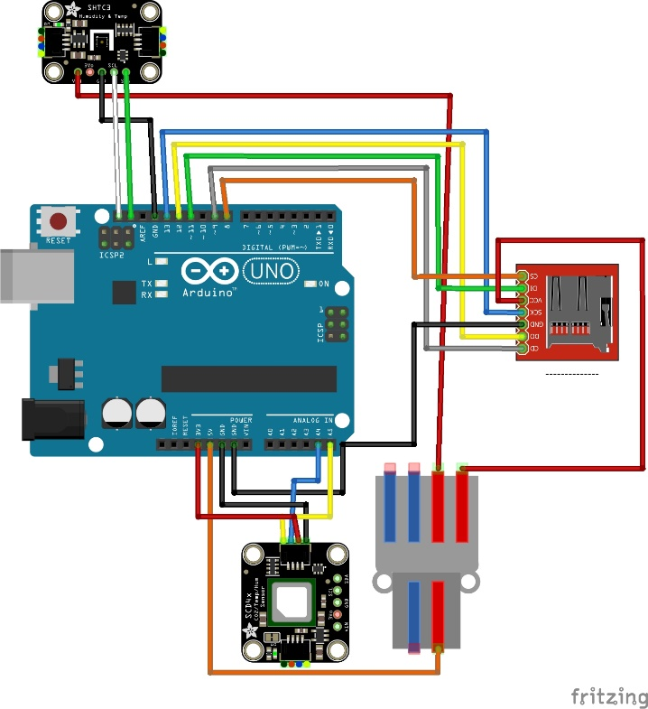

Figure Fritzing connections diagram of the system

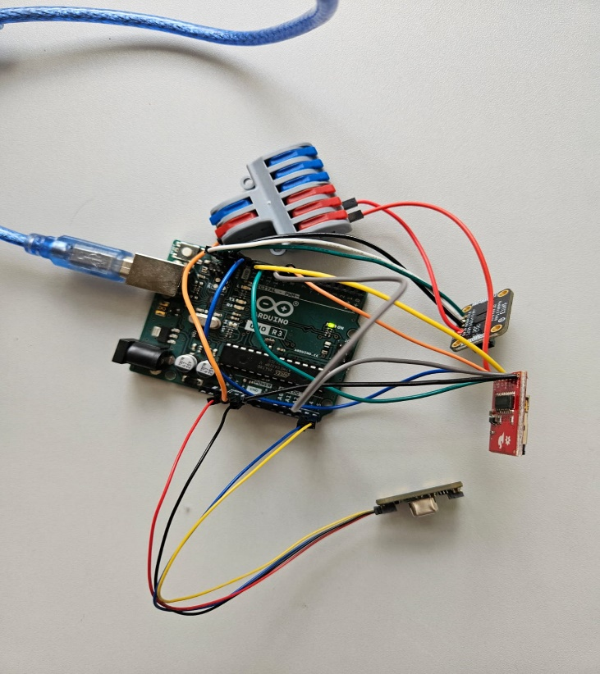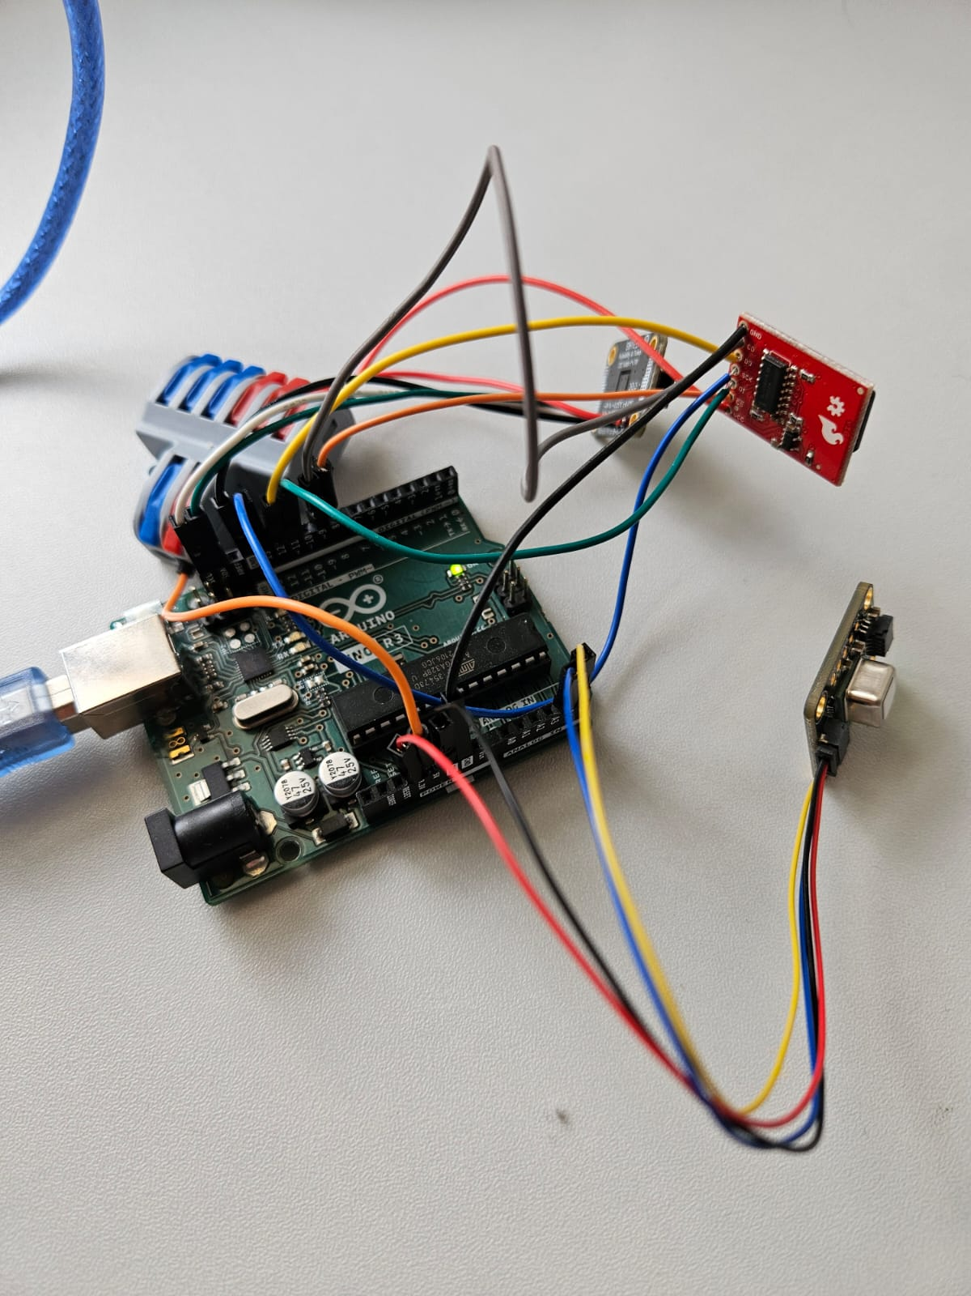

Figure 2 Photos of the system

SHT3C

SCD-40

SPL-42

SD breakout

Arduino Uno

Results:

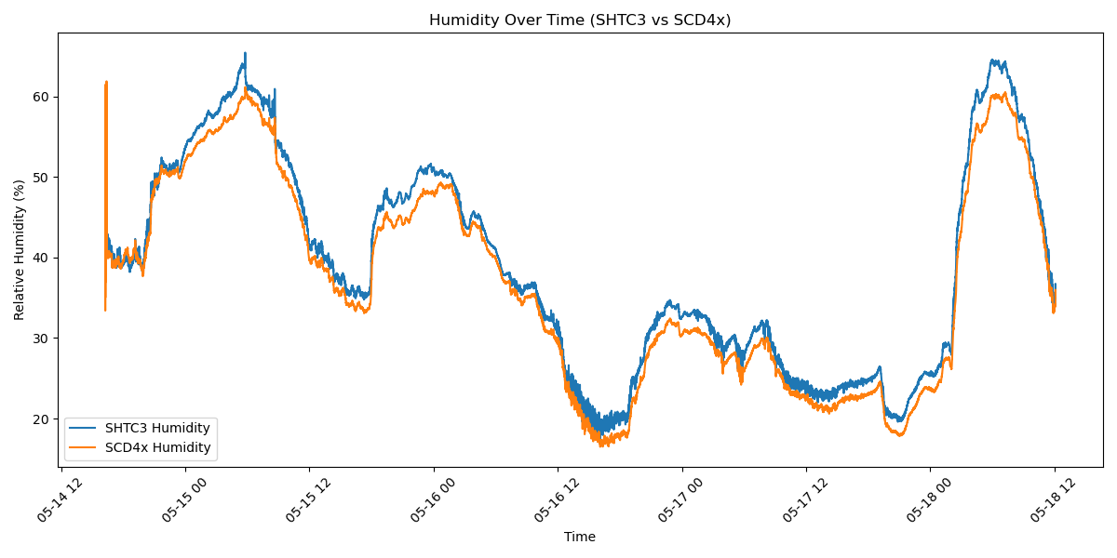

Figure 3 Humidity over time based on SHTC3 (blue) and SCD40 (orange)

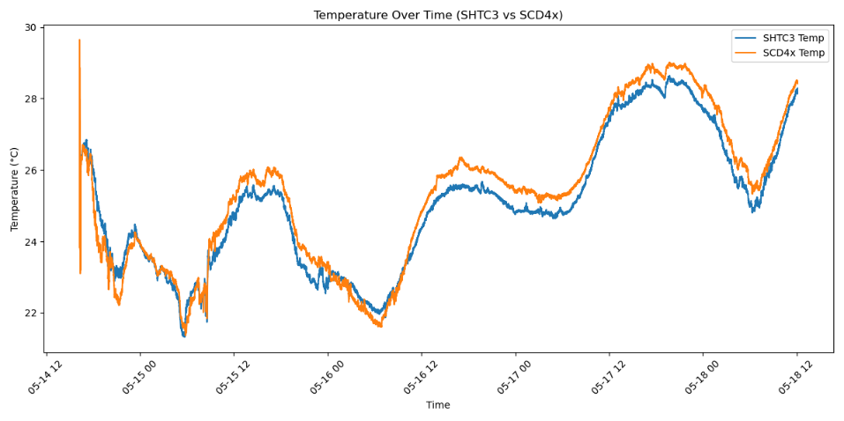

Figure 4 Temperature over time based on SHTC3 (blue) and SCD40 (orange)

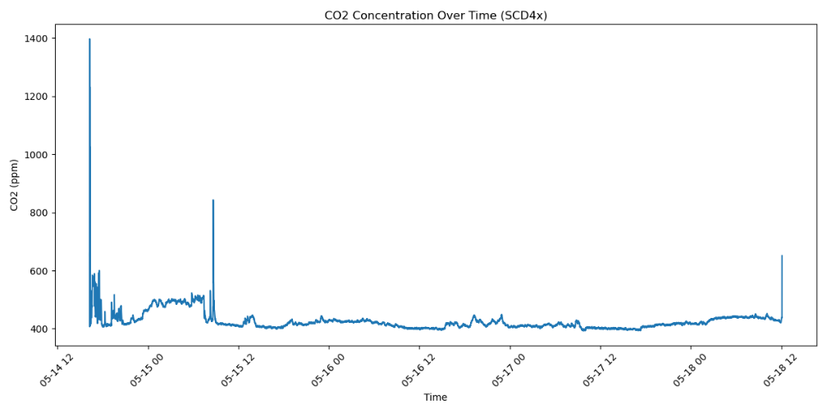

Figure 5 CO2 concentration over time based on SCD40 sensor

Figure 6 Humidity correlation between SHTC3 and SCD40 (A) and temperature correlation between SHTC3 and SCD40 (B)

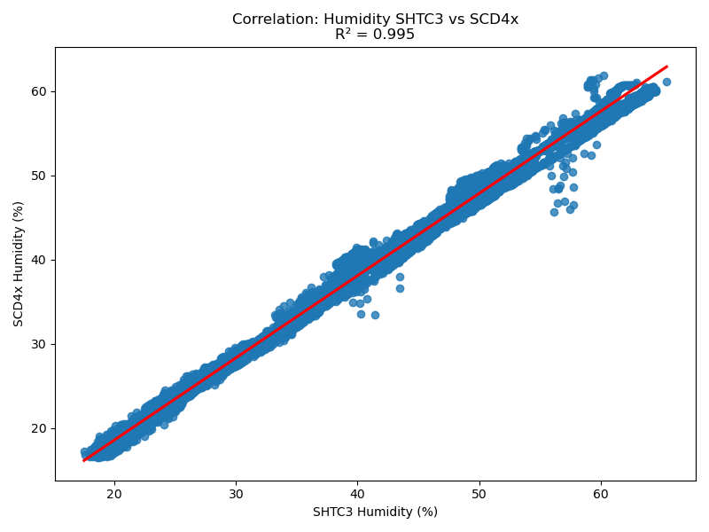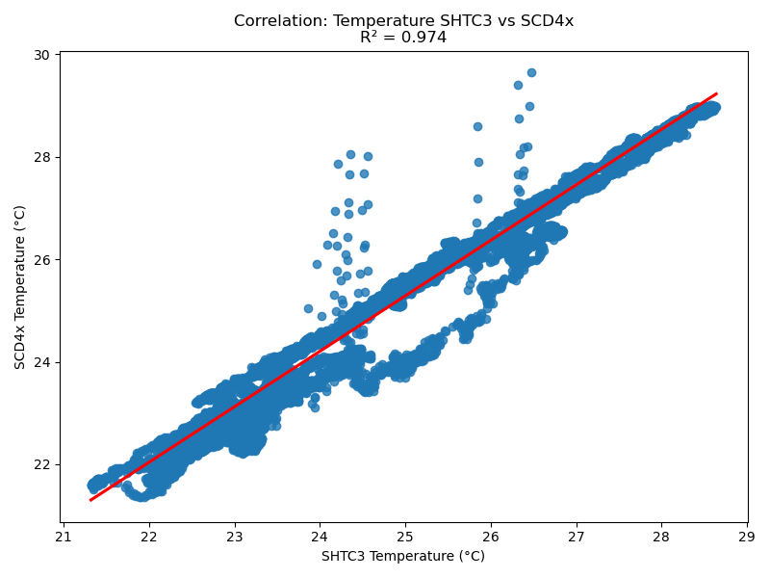

**A**

**B**

Conclusions:

Figures 3 and 4 show that both sensors follow very similar trends for both temperature and humidity, which suggests good agreement between the SHTC3 and SCD40. This is further backed up by the correlation plots in Figure 6, where temperature readings had an R² of 0.974 and humidity readings an R² of 0.955– both indicating strong correlation and reliable measurements.

An interesting pattern can be seen when comparing the humidity and temperature graphs: when one rises, the other tends to drop, which makes sense given their inverse relationship in many indoor environments.

The CO₂ levels, shown in Figure 5, remained steady overall, with a few noticeable spikes. These peaks likely correspond to times when people were present in the apartment. For example, two people were present the first night, one the second, and no one during the remainder of the logging period– which aligns with the changes in CO₂ concentration.

Overall, the system performed well– consistently collecting data and highlighting patterns related to both environmental conditions and human activity. While the LED didn’t function as intended despite troubleshooting, the rest of the setup proved reliable. This project shows that it’s entirely possible to build a low-cost DIY sensor system that can continuously monitor and log temperature, humidity, and CO₂ in a room or office environment.